Physical Education Lesson #10

Hey everyone,

Hope you guys are staying safe and active! Hopefully you are enjoying some of the different exercise and activities we have been providing. Remember that some things may be more difficult than others. That is okay! Just like Phys. Ed. Class at school it is important to try and give your best effort. If you do then you will be successful!- Mr. Feiss and Mrs. Miller

We wanted to try another fun activity that seems to be pretty popular called Cosmic Yoga. It is a great activity that is fun, exciting, and gets everyone active and exercising! The first one we would like you to try is a Pokemon Cosmic Yoga. Everyone loves Pokemon right? Remember to do your best, and have fun with it!

<https://www.youtube.com/watch?v=tbCjkPlsaes>

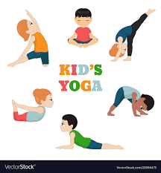 \*\*\*\*At the conclusion of the video, tell your parent or guardian who your favorite Pokemon was and what yoga position you enjoyed doing the most!